Getting Started With Figma: Figma is a powerful, web-based design tool used for creating user interfaces and prototypes. With an intuitive interface, Figma is beginner-friendly yet packed with advanced features for experienced designers. Whether you're designing websites, Figma’s flexible tools and cloud-based nature make it a popular choice for modern design workflows. Starting with Figma involves familiarizing yourself with its frames, layers, and components to create and share designs efficiently.

1.Tools:

The Tools section provides the core functionalities for creating and editing designs efficiently.
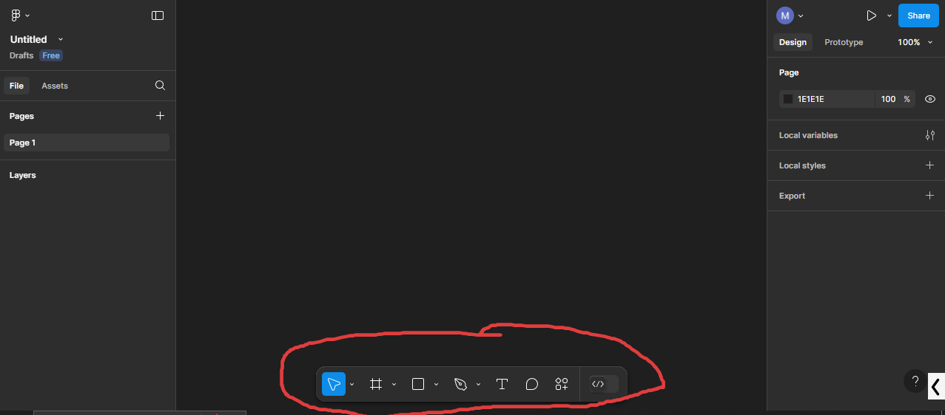

Move Tool
The Move tool allows you to reposition elements on the canvas. Simply click and drag objects to move them, or use the arrow keys for precise adjustments. You can select multiple objects by holding Shift while clicking, enabling group movements.

Scale Tool
The Scale tool is used to resize elements. Drag the corner handles of an object to scale it up or down.

Frame Tool
The Frame tool creates design containers, similar to artboards. To use, select the tool and draw on the canvas. Frames can hold multiple elements and be resized or nested for complex layouts. They are ideal for organizing responsive designs and prototyping.

Shapes (Rectangle, Ellipse, Polygon)
Shape tools enable quick creation of geometric elements. To draw, select the desired shape tool (Rectangle, Ellipse, or Polygon) and click-drag on the canvas. Triple click on the shape to get more detailed editing options.

Pen Tool
The Pen tool creates precise custom paths and vector shapes. Click to create anchor points for straight lines or click-drag to form curves. Close a path by connecting the last anchor point to the first, or leave it open for a line.
Pencil Tool
The Pencil tool is perfect for freehand drawing, offering an organic way to create shapes and paths. Click and drag to draw directly on the canvas. After drawing, you can smooth or adjust the lines for refinement.

Text Tool
The Text tool allows you to add text elements to your design. Click on the canvas to create a text box and start typing. You can adjust font style, size, color, alignment, and line spacing in the properties panel just like Ms word.

2. Design
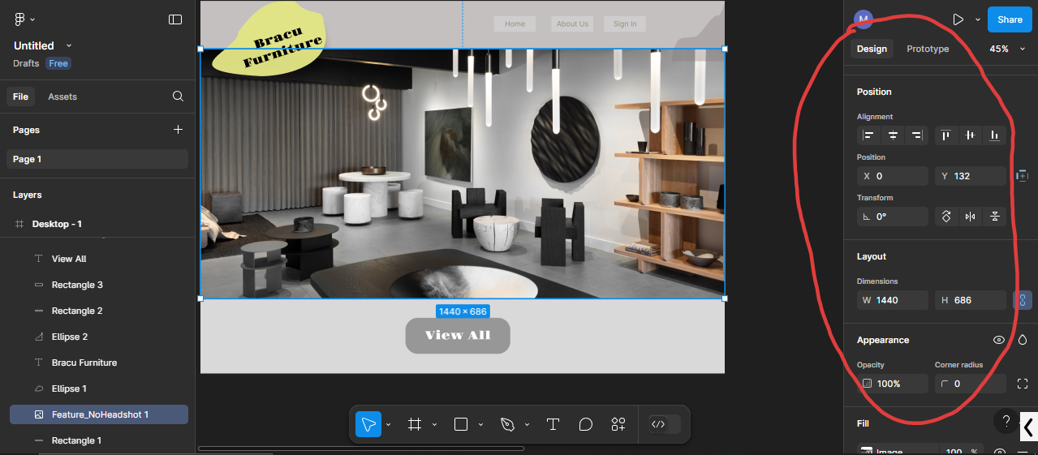

Position and Layout
The Position and Layout tools in Figma provide precise control over object placement and alignment. You can specify exact X and Y coordinates for elements, ensuring they are correctly positioned on the canvas. Layout tools like grids, rulers, and guides further assist in maintaining consistency.
Appearance
The Appearance section provides tools to control the visual properties of an object. You can adjust an element’s opacity to make it partially transparent. The visibility toggle lets you hide objects temporarily for better workspace management.

Typography
Typography in Figma is used to style and organize text. It provides features like font customization, including adjustments to typeface, size, weight, style, and alignment. You can also modify line height and letter spacing to improve readability and create the desired visual hierarchy.
Strokes
Strokes define the borders of an element, allowing you to customize their color, width, and style.
Effects
The Effects section is where you add depth and visual interest to your designs. Common effects include drop shadows, which simulate light and create a sense of layering, and inner shadows, which give a recessed look. Other effects like blur (layer blur and background blur) can create softness or focus on specific elements.

3. Layers
In layout, the stacking order of elements determines what appears on top or underneath. By default, items added later will appear above earlier ones, meaning elements placed higher in the Layers Panel will visually sit "on top" of those below them. Conversely, items lower in the layers are visually covered by those above.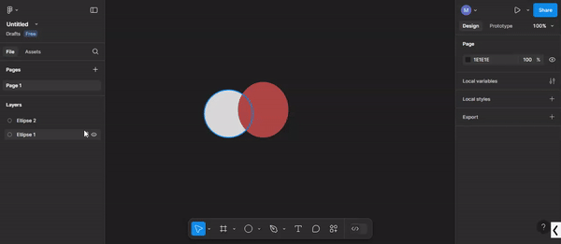

4.Components
Components in Figma are reusable design elements that save time and ensure consistency across your project. For example, imagine you’re designing a website with multiple buttons, and later you need to update their style (like changing the color or corner radius). If each button was created separately, you’d have to edit each one individually—a tedious and error-prone process.
Solution-> Design one button and make it a master component. Then simply copy it and paste to create an instance of that component. If you change the master component all changes would be made to the child components.

5. Prototyping

Prototyping transforms static designs into interactive, clickable mockups, enabling a more realistic preview of user interactions. In the Prototyping mode, you can link frames using interaction lines and define triggers such as “On Click” or “Hover” to initiate transitions like “Slide In” or “Fade.” Prototyping is essential for communicating design intent during presentations or user testing.

Lab Task
1.Create a Figma Account
- Go to figma.com, create an account if you don't already have one, and sign in. Once logged in, you’ll see the Figma interface. Create a new design file by clicking on the "New File" button.
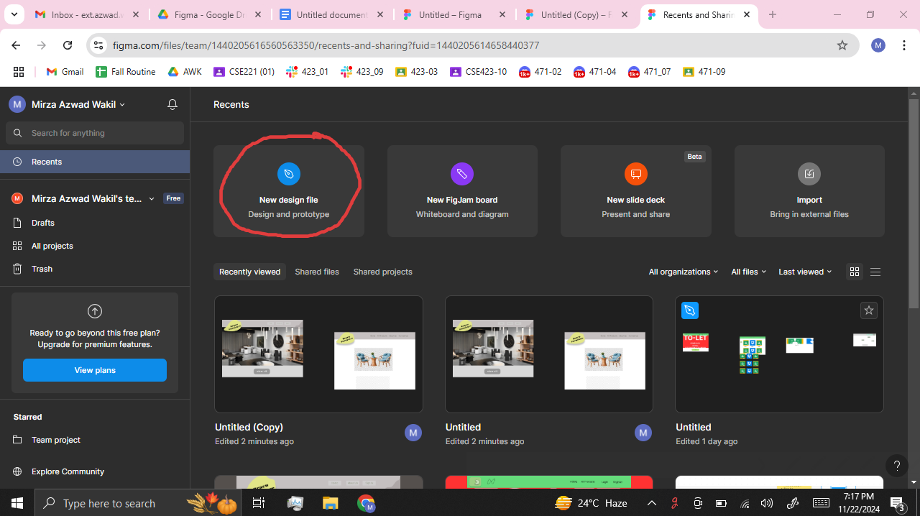

2.Select Frame Tool
- From the Tools section, select the Frame Tool. A list of device options will appear on the right side. Choose TV since modern desktops often have a resolution of 1280x720. After selecting it, a blank white frame will appear on the screen. This will serve as your desktop screen, and you can begin designing within it.

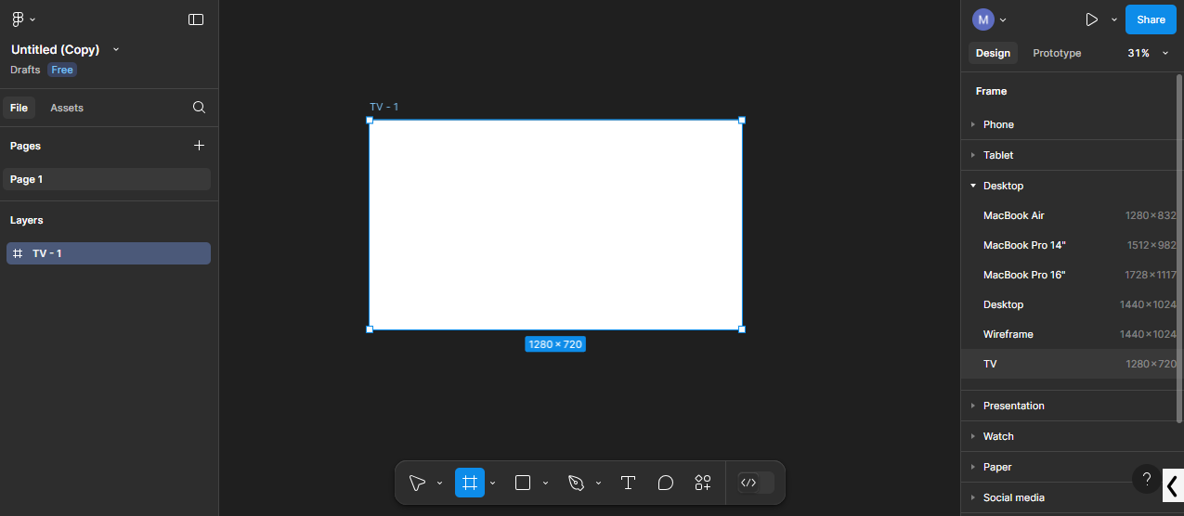

2.Design a Navbar like below.
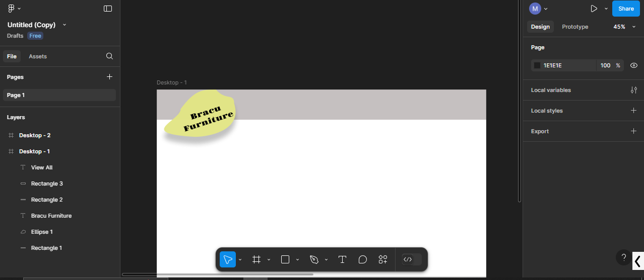

Create a gray box for the navbar:
- Use the Rectangle Tool to draw a rectangle at the top of your frame, and change its color to gray.

Create a gray box for the navbar and design a Logo:
- Use the Rectangle Tool to draw a rectangle at the top of your frame, and change its color to gray.
- Use the Ellipse Tool to draw a circle and set its color to yellow from the Design tab.
- Triple-click on the ellipse to enter advanced shape edit mode and modify it to resemble a logo, as shown in the example.
- 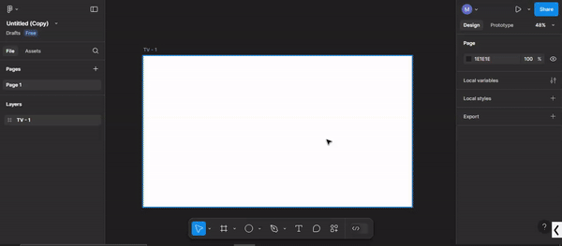

Add text to the logo:
- Select the Text Tool, click inside the logo, and type "Bracu Furniture."
- Select the text and adjust the font style and size using the Typography section in the Design tab (scroll down to find it).
- To rotate the text, use the Transform option under the Position section in the Design tab.
- 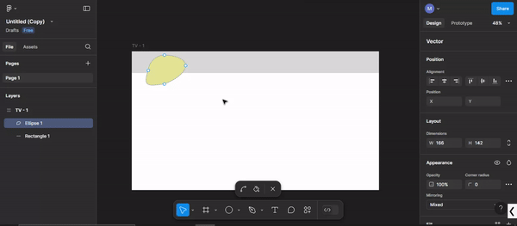

Bonus:You can enhance your design by adjusting the opacity, adding strokes (borders), applying drop shadows, etc. Experiment with these features to make your design more attractive.

4.Insert an Image
- Drag and drop an image from your desktop into Figma, and adjust its size to fit the screen.
- If you notice that the logo is hidden behind the image, adjust the layers. To do this, ensure that the image layer is placed below the ellipse (logo) layer in the Layers Panel.

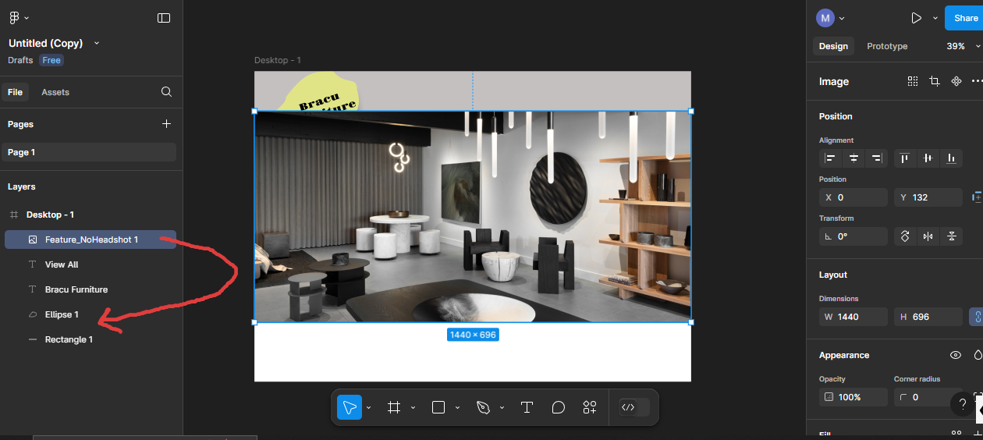

5.Now we want to design buttons like Home, About Us, Sign In etc in the navbar using Components just like the image below

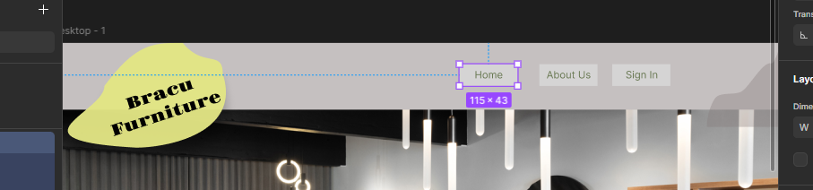

- Design a button (e.g., "Home") using the Rectangle Tool and Text Tool.

- Once the button design is complete, select the button and convert it into a Component by right-clicking and selecting "Create Component." This will be your Master Component.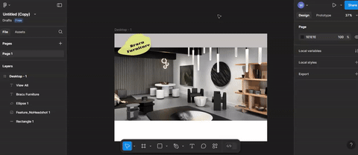

Create instances of the button:
- Copy and paste the master component to create instances (e.g., "About Us," "Sign In").
- Position the buttons as needed. Now, if you make any changes to the master component (e.g., color or size), they will automatically be applied to all instances of the button
- 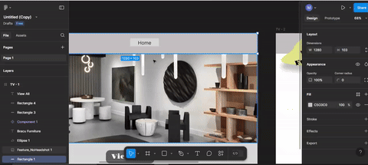

- Once the buttons are placed, complete the rest of the navbar design to match the image below.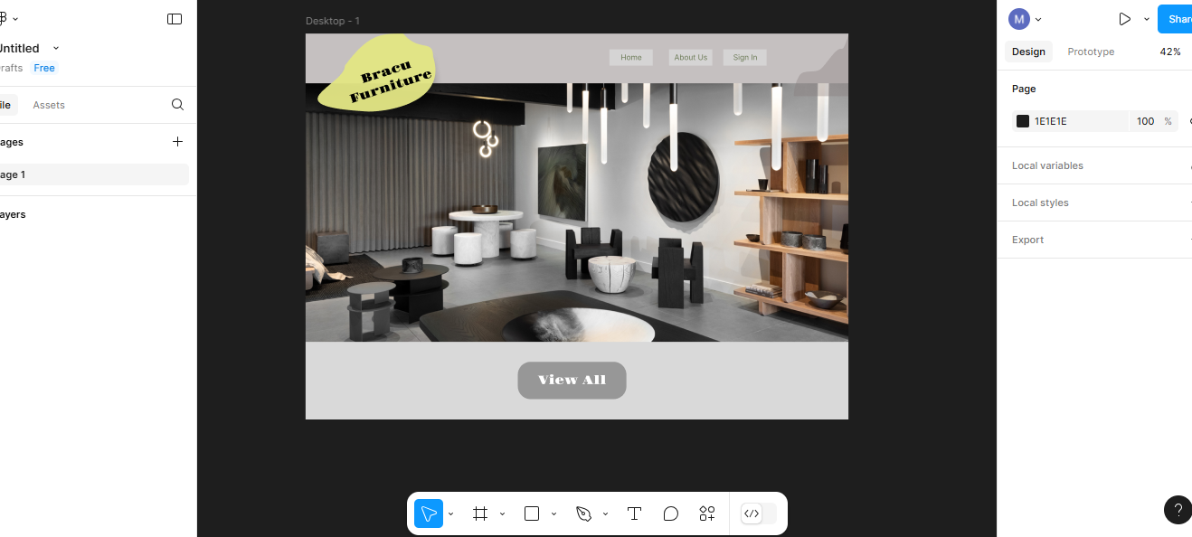

6.Create a New Frame and Design the Layout
- Create another frame for the next section of your design, as shown in the example image.
- Download and use any image you like from the internet to fill the new frame.

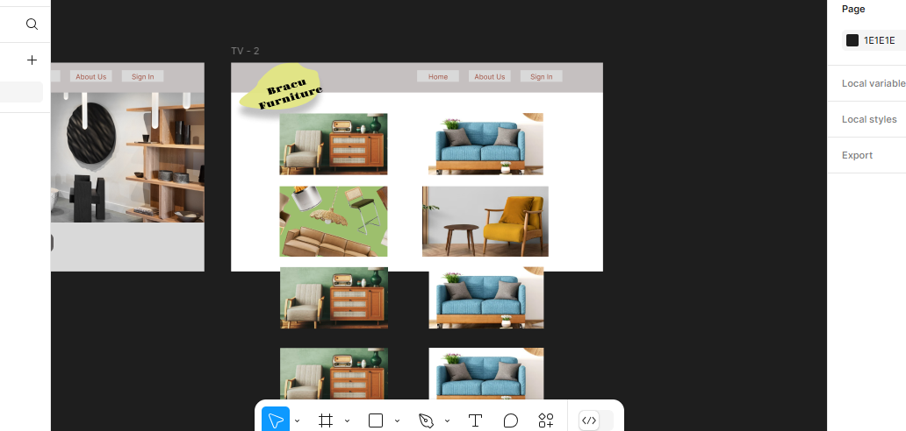

7.Handle Overflow and Scrolling
- If any images extend beyond the frame, we want them to scroll when presenting the design. In order to do so:
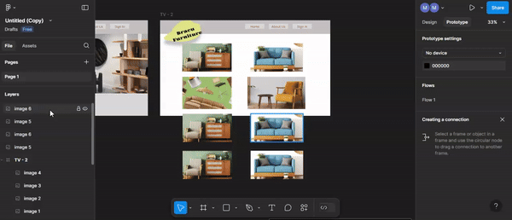
- Make sure all images are within the same parent frame (e.g., TV 2).
- Select all the images , right click on them and make them a group.
- Select the newly created group , right click on it and click on Frame Selection
- Resize the frame and shrink the bottom to adjust with the main frame.
- Finally go to the Prototype tab and change the Overflow to Vertical. That's it.

8.Create a Prototype
- Switch to the Prototype tab to add interactivity.
- Hover over the "View All" button and click the plus sign that appears. Drag an arrow to connect it to the second frame.
- Similarly, connect the "Home" button on the second frame to the first frame.
- Click on the Present button in the top-right corner to preview your interactive design. This will simulate the website, and you can navigate through the connected pages.
By following these steps, you will create a functional and interactive design prototype
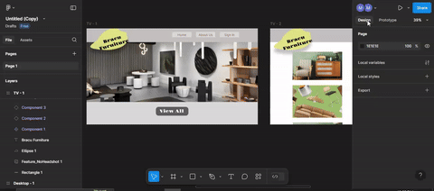

9. Designing Login Page
- Create another frame and design a simple login page using basic design tools like below
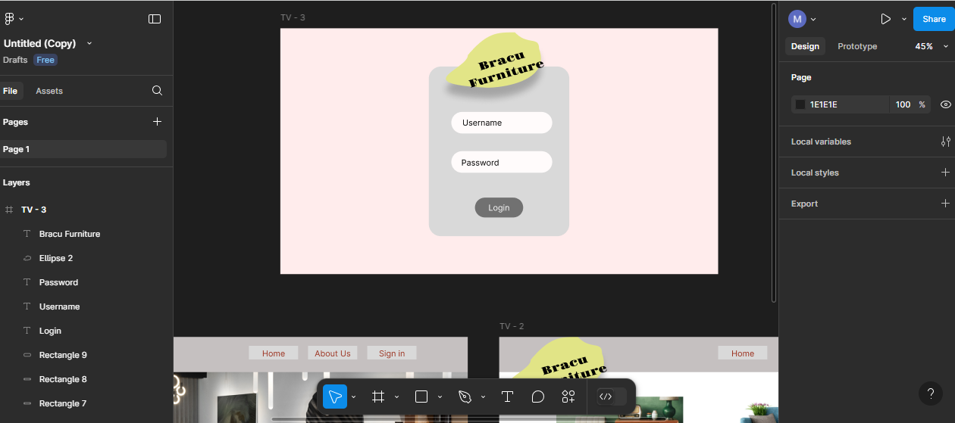

- Create Component: Drag the username field (label + input box) out of the frame, then select it and right-click > Create Component.
- Add Variant: With the component selected, click the "Add Variant" button to create a second variant.
- Edit Second Variant: In the second variant, edit the "Username" text and replace it with a cursor sign ‘|’ .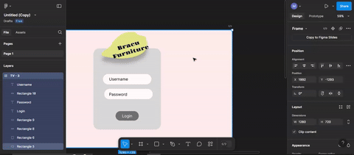
- Prototype Setup: Go to the Prototype tab, connect the two variants with an "On Click" interaction to switch between them.
- Drag to Page: Go to Assets > Local Components, drag your comp
- Test: Click Play to test. The username field should change to a cursor when clicked.

These were some basic things of figma but surely this is not the end. There is a lot more to discover and learn. Have fun experimenting with Figma’s features, and don’t hesitate to explore and discover other new hidden features in Figma.

